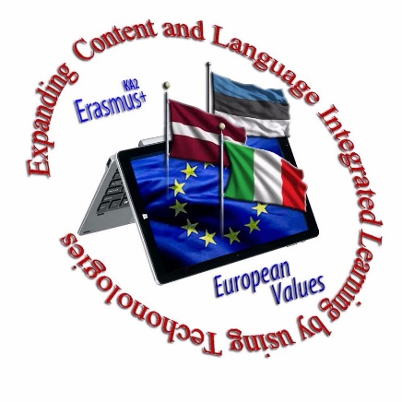
Rīgas Angļu ģimnāzija no 2017. g. 1. septembra realizē divgadīgu Erasmus + projektu “Expanding Content and Language Integrated Learning by Using Technologies". Projektā piedalās 3 valstu – Latvijas, Igaunijas un Itālijas skolotāji un skolēni, stiprinot gan tehnoloģiju, gan valodas un satura integrētu apguvi (CLIL) Skype stundās un klātienes tikšanās reizēs.
No 26. - 30.11.2018. notika mobilitāte Tallinā.

Participants:
• Latvia (Riga English Grammar School) – 5 students, 3 teachers
• Italy (Istituto di istruzione superiore «M. Bartolo») – 5 students, 3 teachers
• Estonia (Pelgulinna Gymnasium) 13 students, 8 teachers
Mobility activities:
• Presentation about schools and multicultural face-to-face collaboration;
• 12 CLIL classes in different subjects;
• Drama and movie making activities (scenario, filming, and editing);
• Outdoor lessons (using CLIL) for learning about national culture and history;
• STEAM education and Robotic Fair visit.

